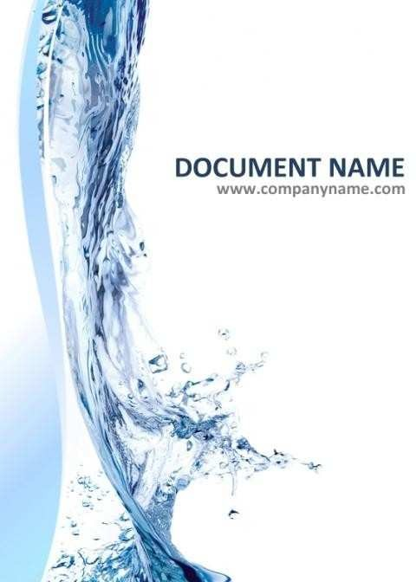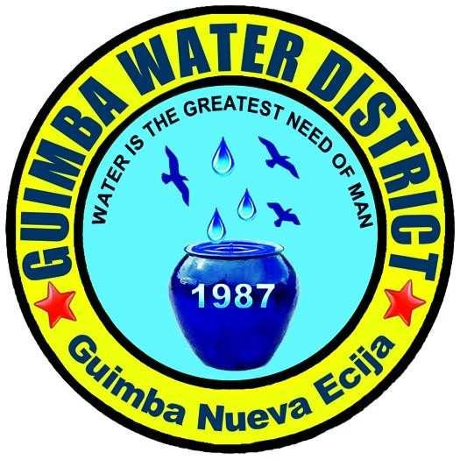

## TABLE OF CONTENTS

Introduction 3

Definition of Term 4

General Information

Profile of GWD 5

Mission & Vision 6

Performance Pledge 6

Areas of Operation 7

Organization and Responsibilities Organizational Structure

Board of Directors 8

GWD Organizational Chart 9

Duties and Responsibilities 14

Operating Procedures

Applying for new service connection 17

Payment of water bills 18

Reconnection of Disconnected Line 19

Request for temporary or Voluntary Disconnection 20

Request for Change of Name 21

Complaint on Service Line Leaks 22

Transfer/ Relocation of Water Meter 23

Issuance of Office Supplies 23

Receipts of Deliveries of Inventory 24

Issuance of Construction Materials 25

Procurement Process

Office Supplies 26

Service Connection Materials 26

Disbursement Process 27

Production 28

Receipts & collection Process 29

## INTRODUCTION

The Operations Manual of Guimba Water District (GWD) contains the general information about the agency, its underlying function, mandates, operating procedures and organization.

The purpose of this manual is to provide its readers knowledge about the district’s responsibilities and structure.

The manual is divided into several parts, as follows:

**GENERAL INFORMATION** – this section contains the profile, such as the brief history of GWD, mandates and functions, its mission and vision, performance pledge, pumping stations and areas of operation.

**ORGANIZATION AND RESPONSIBILITIES** – in this part of the manual, the organizational structure was shown using a diagram as of year 2018, as well as the duties and responsibilities of every employee.

**OPERATING PROCEDURES** – contains the step-by-step procedures and work instructions of GWD. Activity flow charts are used to illustrate the different processes involved in daily operation

## DEFINITION OF TERMS

GWD – Guimba Water District

S.I.R.M.O – Sr. Industrial Relations Management Officer

I.R.M.O. – Industrial Relations Management Officer

W.R.F.O. – Water Resource Facilities Operator

W.M.M. – Water Maintenance Man

C.S.O. – Customer Service Officer

P.O. – Purchase Order

R.F.Q. – Request for Quotation

P.R. – Purchase Request

BAC – Bids and Award Committee

D.V. – Disbursement Voucher

S.D. – Supporting Documents BUR – Budget Utilization Request PhilGEPS – Philippine Government Electronic Procurement System

## GENERAL INFORMATION

**GUIMBA WATER DISTRICT (GWD)** was formerly owned, managed and operated by the Municipal Government with Eng'r. Eulogio D. Valeroso, Sr. as General Manager. The water is governed by a Board of Directors with Mr. Domingo de Luna as the first Chairman.

Sometime in 1987, P.D. 198 was issued declaring a national policy favoring local operation and control of the water systems and authorizing the formation of local water districts and providing for the government the administration of such districts. In compliance thereto, GWD was formally transferred by the Municipal Government of Guimba represented by the Mayor Virgilio V. Calica to Eng'r. Eulogio D. Valeroso, Sr. by the way of a Deed of Transfer dated May 29, 1987 which included all physical assets, machineries, buildings and receivables.

The GWD operates through the leadership of the General Manager who is appointed by the Board of Directors. GWD policies, rules and regulations on the other hand, are created by the Board of Directors through a board resolution. Number of staffs and top management and tariffs are under government regulation.

GWD is now categorized as Category C Water District as of March 31, 2012. As of February 2018, out of 64 Barangays, 60 Barangays were served with a total service connection of 10,810.

# PANANAW

Upang makapaghatid ng malinis at ligtas na tubig na dadaloy sa bawat tahanan ng Guimba sa pinakamababang halaga na abot kaya at tapat na paglilingkod

# MISYON

Makapagbigay ng lubos na kasiyahan sa aming mga taga tangkilik ng serbisyo ng tubig sa pamamagitan ng pagbibigay ng ligtas, malinis, masaganang tubig at isang pantay-pantay at tapat na paglilingkod sa abot ng aming makakaya.

# PERFORMANCE PLEDGE

We,

the officials and employees of GUIMBA WATER DISTRICT, are committed to serve with integrity, honesty and professionalism,

to deliver a potable,

adequate and affordable supply of water.

# AREAS OF OPERATION

|  |  |
| --- | --- |
| **BARANGAYS SERVED BY GWD AS OF FEBRUARY 2018** | |
| **1. AGCANO** | **32. MAYBUBON** |
| **2. AYOS LOMBOY** | **33. NAGLABRAHAN** |
| **3. BACAYAO** | **34. NAGPANDAYAN** |
| **4. BAGONG BARRIO** | **35. NARVACAN I** |
| **5. BALBALINO** | **36. NARVACAN II** |
| **6. BALINGOG EAST** | **37. PACAC** |
| **7. BALINGOG WEST** | **38. PARTIDA I** |
| **8. BANITAN** | **39. PARTIDA II** |
| **9. BANTUG** | **40. PASONG INCHIK** |
| **10. BUNOL** | **41. SAINT JOHN** |
| **11. CABALLERO** | **42. SAN AGUSTIN** |
| **12. CABARUAN** | **43. SAN ANDRES** |
| **13. CALEM** | **44. SAN BERNARDINO** |
| **14. CAMIING** | **45. SAN MARCELINO** |
| **15. CARDINAL** | **46. SAN MIGUEL** |
| **16. CASONGSONG** | **47. SAN RAFAEL** |
| **17. CATIMON** | **48. SAN ROQUE** |
| **18. CAVITE** | **49. STA. ANA** |
| **19. CAWAYAN BUGTONG** | **50. STA. CRUZ** |
| **20. CONSUELO** | **51. STA. LUCIA** |
| **21. CULONG** | **52. STA. VERONICA** |
| **22. ESCAÑO** | **53. STO. CRISTO** |
| **23. FAIGAL** | **54. SARANAY** |
| **24. GUISET** | **55. SINULATAN** |
| **25. LAMORITO** | **56. SUBOL** |
| **26. LENNEC** | **57. TAMPAC I** |
| **27. MACAMIAS** | **58. TAMPAC II & III** |
| **28. MACATCATUIT** | **59. TRIALA** |
| **29. MANACSAC** | **60. YUSON** |
| **30. MANGGANG MARIKIT** | **61. BULAKID** |
| **31. MATURANOC** | **62. CAINGIN** |

|  |  |
| --- | --- |
| **PUMPING STATION YEAR CONSTRUCTED** | |
| **STA. VERONICA** | **1967** |
| **BANTUG** | **2001** |
| **SAN ROQUE** | **2001** |
| **MATURANOC** | **2009** |
| **BACAYAO** | **2010** |
| **SAN ANDRES** | **2010** |
| **SAN RAFAEL** | **2017** |

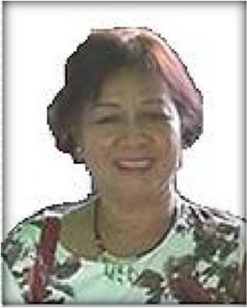

SOL B. LACSON MEMBER

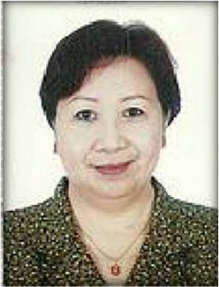

CONCHITA G. DOMINGO MEMBER

## BOARD OF DIRECTORS

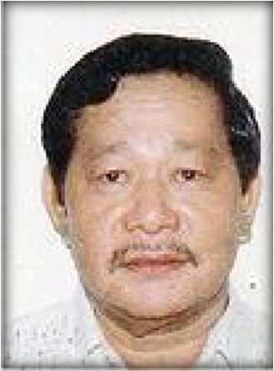

**THOMAS MAXDOLEY C. LEYVA**

CHAIRMAN

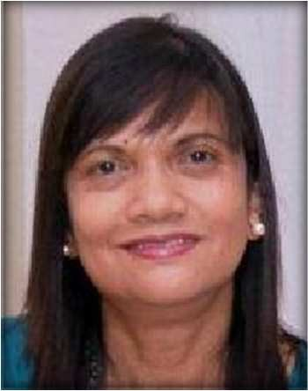

ALORA G. CORPUZ MEMBER



RAQUEL C. ABUAN MEMBER

**ORGANIZATIONAL CHART**

**GENERAL MANAGER C**

**Eng’r. Felixberto C. Legarda**



**EXECUTIVE ASSISTANT C**

**Catherine M. Legarda**

**DIVISION MANAGER C**

**FINANCE**

**Mary Grace DC. Batangan**

**DIVISION MANAGER C**

**ADMINISTRATIVE**

**Aristotle G. Muñoz**

**DIVISION MANAGER C**

**PRODUCTION**

**Rommel G. Gragasin**

**DIVISION MANAGER C**

**ENGINEERING**

**Francis E. Esquivel**

**ORGANIZATIONAL CHART**

**ADMINISTRATIVE DIVISION**

**DIVISION MANAGER C**

**ADMINISTRATIVE**

**Aristotle G. Muñoz**

**SR. INDUSTRIAL RELATION MNGT. OFFICER A**

**Rodrigo T. Alcantara**

**COMPUTER OPERATOR**

**Lykha A.Gutierrez**

**CUSTOMER SERVICE OFFICER A**

**Diane Erica DG. Barawid**

**CUSTOMER SERVICE OFFICER A**

**Susana G. Barawid**

**CUSTOMER SERVICE ASSISTANT C**

**VACANT**

**CUSTOMER SERVICE ASSISTANT C Rochelle Ann C. Catingting**

**INDUSTRIAL RELATION MNGT. OFFICER A**

**Anne Clarisse C. Romano**

**PUBLIC RELATION OFFICER B**

**Danilo O. Mañago**

**PROPERTY SUPPLY OFFICER B**

**Elmer G. España**

**PROPERTY SUPPLY OFFICER B**

**Cielito Lindo G. Marzan**

**UTILITY WORKER A**

**Vacant**

**UTILITY WORKER A**

**Ninos D. Binuya**

**DRIVER**

**Vacant**

**DRIVER**

**Carluen M. Guiang**

**CARPENTER A Rodelio R. Cezar**

**ORGANIZATIONAL CHART**

**FINANCE DIVISION**

**DIVISION MANAGER C**

**FINANCE**

**Mary Grace DC. Batangan**

**CORPORATE BUDGET SPECIALIST B**

**Vacant**

**SENIOR CASHIER Mark Angelo F. Sarmiento**

**SR. CORPORATE ACCOUNT ANALYST Jennilyn Joy M. Acosta**

**CASHIER C Joyce Ann DV. Dela Cruz**

**ACCOUNTING PROCESSOR A Lianna Ross T. Columbino**

**ORGANIZATIONAL CHART**

**PRODUCTION DIVISION**

**DIVISION MANAGER C**

**PRODUCTION**

**Rommel G. Gragasin**

|  |
| --- |
| **WATER RESOURCES FACILITIES OPERATOR A** |
| **Ronald Allan L. Vigilia** |
| **Amory D. Santos** |
| **Reynaldo R. Cunanan** |
| **Ger Christian DR> Corpus** |
|  |
| **WATER RESOURCES FACILITIES OPERATOR B** |
| **Mike Oliver C. Cabiling** |
| **Marc Gregoree Lourde M. Wy** |
| **Jhead S. Villaruel** |
| **Alvin M. Eugenio** |
| **John Philip R. Batangan** |
| **Richard A. Fiesta** |
| **Juan Miguel G. Pantaleon II** |

|  |
| --- |
| **WATER RESOURCES FACILITIES OPERATOR A** |
| **Ronald Allan L. Vigilia** |
| **Amory D. Santos** |
| **Reynaldo R. Cunanan** |
| **Ger Christian DR> Corpus** |
|  |
| **WATER RESOURCES FACILITIES OPERATOR B** |
| **Jose Angelo S Agapito.** |
| **Eugenio G. Taberna** |
| **Ron-Ron C. Refugia** |
| **Mark Ferdinand T. Bernardo** |
| **Edward A. Galdonez** |
| **Christoniel L. Batangan** |
| **Vacant** |

**ORGANIZATIONAL CHART**

**PRODUCTION DIVISION**

**DIVISION MANAGER C**

**ENGINEERING**

**Francis E. Esquivel**

**WATER MAINTENANCE FOREMAN**

**Thaddeus John B.** **Beltran**

**WATER MAINTENANCE FOREMAN**

**Armando P. Pisantes**

**SUPERVISING ENGINEER A**

**Dexter Norven S.** Pagoso

|  |
| --- |
| **SR. WATER**  **MAINTENANCE MAN A** |
| **Mario M. Galo** |
| **Rauderick A. Ramos** |
|  |
| **WATER**  **MAINTENANCE MAN A** |
| **Eduardo M. Ador Dionisio** |
| **Hilario B. Fernando** |
| **Dionisio V.,Baricuatro** |
| **Joel B. Tabing** |
|  |
| **WATER**  **MAINTENANCE MAN B** |
| **Sonny L. Francisco** |
| **Jonathan T. Pascual** |
| **Edwin P. Diaz, Jr.** |
| **Ariel DG. Mata** |
| **Paul S. Gatchalian** |
| **Radney C. Miranda** |
| **Manolito C. Peralta Jr.** |

|  |
| --- |
| **SR. WATER**  **MAINTENANCE MAN A** |
| **Noel D. Galapon** |
| **Ted U.Yambot** |
|  |
| **WATER**  **MAINTENANCE MAN A** |
| **Jick-Jick F. Gamboa** |
| **Roberto C. Rigos** |
| **Joan May C. Eugenio** |
| **Evelita R. Javier** |
|  |
| **WATER**  **MAINTENANCE MAN B** |
| **Melchor M. Javier** |
| **Crisanto C. Tamayo** |
| **Ralp DC. Ramos** |
| **Alfidel B. Solomon** |
| **Manuel P. Gallardo** |
| **Vacant** |
| **Vacant** |
| **Vacant** |
|  |

**ENGINEERING ASSISTANT A**

**Vacant**

## DUTIES AND RESPONSIBILITIES

**PRIMARY FUNCTION**

The board of directors is the making body. Ensures the availability of adequate financial resources and approves annual budget.

The general manager shall have full supervision and control of the operation of water district with power and authority to appoint all personnel of the district as provided in PD 198.

### DIVISION MANAGER – ADMIN.

 Act as the Officer-In-Charge for Administrative and General Services Division

 Supervises the activities of all personnel with administrative functions, evaluate staff performance and prepare reports and recommendations to the management.

 Other duties that may be assigned by the General Manager

### DIVISION MANAGER – FINANCE

 Act as the Officer-In-Charge for Finance and Commercial Division

 Supervises financial operation and maintain records of financial transactions of the district

 Other duties that may be assigned by the General Manager

### DIVISION MANAGER - ENGINEERING

 Act as the Officer-In-Charge for Engineering and construction division

 Supervises the engineering works of the district and prepare reports and recommendation to the management

 Other duties that may be assigned by the General Manager

### DIVISION MANAGER - PRODUCTION

 Officer-In-Charge for production and quality services.

 Supervise the water production of the district and its quality and/or potability

 Prepare report of water production and prepare schedule of Water Resources Facilites Operators

 Other duties that may be assigned by the General Manager

### S.I.R.M.O. / I.R.M.O.

Maintain records of employees including contractual (daily time record, leaves, etc.) Inform personnel regarding District C.S.C and D.B.M. policies, rules and regulations. Acts as Employees queries, request and complains regarding personnel matters.

Other duties assigned by the Superiors.

- Act as Liaison Officer of the District.

### SENIOR CASHIER

Receive, record daily collections and deposit the same.

Keeps, maintains and prepares report of daily collections for office records. Other duties assigned by the superior

### SR. ORPORATE ACCOUNT ANALYST

**C**

**P**

**SH**

**E**

**C**

**RP**

Prepares financial statement of the district. Keeps and maintains financial records.

Prepares duties assigned by the superior.

### SUP LY OFFICER

Received office supplies, materials, tools & equipment, etc. and issue the same. Record issuance of supplies & materials and maintain accountability.

Make an inventory of all materials at least 2x a year. Other duties that maybe assigned by the superiors.

### CA IER C

Assists the cashier in the collection of payments.

Prepares vouchers and records collection & disbursement vouchers.

Other functions related to the job as may be delivered by the GM and/or superiors.

### SUP RVISING ENGINEER

Does the engineering works of the district.

Oversee the repair of the building, pump houses and distribution lines of the district. Does other function related to the job as may be directed by the GM and/or superiors.

### EXE UTIVE ASSISTANT

Act as secretary to the General Manager Received incoming calls for the District.

Other duties that maybe assigned by the superiors.

### CA ENTER

Serve as the official carpenter of the district.

Restore & repair damaged office building & pump houses.

Other duties that maybe assigned by the GM and/or supervisors.

### WATER RESOURCES FACILITIES OPERATOR

Operates & maintain electric motor, diesel engine and pumping unit. Mix solution of chlorine to maintain water quality and/or portability.

Maintain the cleanliness of the water reservoir, pump & diesel engine house and its perimeter.

 Perform guard services during duty.

### WATER MAINTENANCE MAN

Laying of water pipes and tapping of new connections. Disconnects delinquent concessionaires & reconnect the same. Repair leaks & other water facilities.

 Perform other plumping works as necessary and maybe assigned by superiors.

### METER READERS

Reads water meters of the district concessionaires. Serves water bill notices and notice of disconnection.

Disconnects delinquent concessionaires & reconnect the same. Report leaks, illegal connections and water meter for relocation.

### CUSTOMER SERVICE OFFICER

 Supervises customer service assistant/meter readers.

 Recommend customer’s request and complaints for proper action from time to time.  Other duties that may be assigned by the supervisor and the General Managers.

### WATER MAINTENANCE FOREMAN

 Supervise the laying of pipes and tapping of new connections.  Leads the disconnection of delinquent concessionaires

 Supervises the repair of leaks, installation of fire hydrants and control gate valve and other water facilities.

 Perform other plumbing works and other duties that may be assigned by the superiors from time to time.

**UTILITY WORKER**

 Maintain the cleanliness of the office and office perimeters.  Other duties that may be assigned by the superiors.

### DRIVER

 Official driver of the district.

 Other duties that may be assigned from time to time by the supervisors.

## OPERATING PROCEDURES

**APPLYING FOR NEW SERVICE CONNECTION**



Proceed to front desk, fill-up

application form and submit to Customer Service Assistant.

Check if the application form is completely filled out

Inspection of service location and determine if service line can be install.

Duration: within 1 -3 working days

Is the area

connection?

Compute all necessary cost for service connection and issue cost

assessment to concessionaire.



Return to GWD Office and proceed to customer service desk. Pay all necessary fees.

STEP 2



Accept payment for new service connection and issue official receipt.

Duration: 2 mins



signing ofcontract.



STEP 1

17



END



Proceed

**To**

Step 2



Briefing for guidelines & policies of GWD.

Duration: 3-5 mins.

Installation of service line.

Duration: 2-5 working days



**EN**D



Is the

receipt?

Proceed to the cashier for the issuance of the official

receipt.

Verifies account and collect payment

and issue official receipt.



## PAYMENT OF WATER BILLS



Goto GWDOffice forpayment of Water bill



18



**END**

## RECONNECTION OF DISCONNECTED LINE



Proceed to customer service and request for reconnection.

Verify concessionaires account if there’s unpaid bills & pull out meter.

Pay unpaid bills, materials and reconnection fee.

Is there any

Pay reconnection fee.

Duration: 3 mins

Collect payment and issue official receipt

Duration: 5 mins

Process the request and prepares action report and service request form.

Duration: 3 mins

19



Reconnect water service.

Duration: 1-2 days

## REQUEST FOR TEMPORARY OR VOLUNTARY DISCONNECTION



Verify the status of concessionaires account.

Duration: 2 mins.

Isthereany

bills?

**CASHIER**

Collect payment and issue official receipt

Duration: 5 mins

**CUSTOMER SERVICE OFFICER**

Prepare work order for disconnection.

Duration: 2 mins.

disconnect water service. Duration: 1-2 working days



Pay the unpaid bill.



20



Proceed to customer service and request for disconnection.

## REQUEST FOR CHANGE OF NAME

21



As for authorization letter for

change name to previous

to

step 2



Proceed to customer service and request for change of name.

STEP 1



Find request letter for change of name of concessionaire with signature.



Is there a

name?



Encode for change of name Duration: 5 mins.

**END**



Back to GWD office with the requirements.

STEP 2



Verify the letter if valid.

Duration: 5 mins



## COMPLAINT ON SERVICE LINE LEAKS



Proceed to customer service and request for check/repair of service line leak.



Write the concessionaires name, address, reason of complain. Explain probable cause and solutions. Prepare action report. Duration: 10-15 mins.

Check and repair service line leak Duration: 1-2 working days



**END**

22

## TRANSFER/RELOCATION OF WATER METER

23



Prepare and issue cost assessment to concessionaire.

Duration: 5 mins



Proceed to customer service and request for transfer location tapping.

STEP 1



Verify and check the status of concessionaires account.

Duration: 5 mins.

Inspect relocation area Duration: 1-2 working days

meter?



**END**



to step 2



Return to GWD Office and proceed to customer service desk. Pay all necessary fees & materials.



Collect payment and issue official receipt

Duration: 5 mins



Prepare work order for transfer location tapping.



Installation of service line. Duration: 3-5 working days

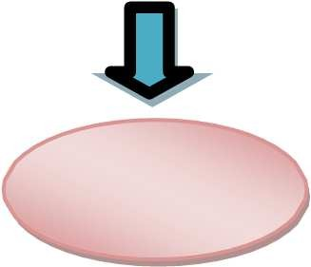

**END**



STEP 2



## ISSUANCE OF OFFICE SUPPLIES



Stock

Requisition and issuance



Purchase request



Update inventory system supplies ledger card

## RECEIPTS OF DELIVERIES OF INVENTORY



Delivery Receipt



Inspection and



Inventory System

24

## ISSUANCE OF CONSTRUCTION MATERIALS



Requisition slip / construction order



**SUPPLY OFFICER**

Prepare and issue materials.

Duration: 10 mins



**WATER MAINTENANCE MAN**

Received the materials.

Duration: 5 mins



**SUPPLY OFFICER**

Record the materials issued to ledger card.



Encode and update the materials in the inventory.

25

## PROCUREMENT PROCESS

## OFFICE SUPPLIES



Purchase Request (PR)



(RFQ) Abstract of Quotation



Purchase order (PO)

## SERVICE CONNECTION MATERIALS



Purchase Request (PR)



Request for Quotation (RFQ)



PhilGEPS POSTING

P50,000.00-P999,000.00

RFQ

PUBLIC BIDDING P1M ANDABOVE



(BAC Resolution)

26



NOA, PO, NTP

## DISBURSEMENT PROCESS



BUS



SDs, BUR



**SR. CORP. ACCT. OFFICER**

Check documents received, certifies the Budget Utilization Request (BUR) Forwards to accounting for processing



Approves Transaction



Verifies claim and certifies fund availability.



DV, SDs, BUR



Prepares and signs check



DV, SDs, BUR,

check



Countersigns Check



Records transaction to check Disbursement Journal



DV, SDs, BUR,

check



Release check to claimant

27

## PRODUCTION



Source/ well



Operation



with chlorinefor disinfection



Disinfected water will then

consumer’s service line



to prevent line breakage

**\*GWD’s Water Safety Plan was acknowledged on March 24, 2015 by World Health Organization (WHO) and Department of Health (DOH).**

28

## RECEIPTS AND COLLECTION PROCESS



Receive payment from

Official Receipt



of collection and deposit



Deposit Collections

29